Q-1. Write an SQL query to print the first three characters of FIRST_NAME from Worker table.
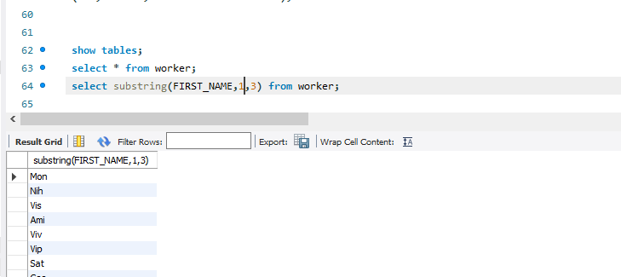

Q-2. Write an SQL query to find the position of the alphabet (‘a’) in the first name column ‘Amitabh’ from Worker

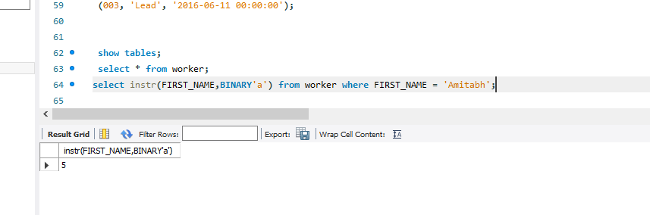

Write an SQL query to print the name of employees having the highest salary in each department.

